Mathematics Test – Computing – January 21 - 1st Sit
UNIVERSITY OF ROEHAMPTON ©

Undergraduate Degree Examinations
for students registered with the University of Roehampton
Module code: QAC020B014A

Module title: Operational Mathematics Test
For Office Use Only

Assessment period: January 2021
$\frac{ }{50}$
$$\%$$
Type of paper: Revealed

Time allowed: Online
Dictionaries
International students whose first language is not English may bring in a standard paper-based translation dictionary. No form of electronic dictionary is permitted.

Calculators
Calculators are allowed for this test. Calculators on mobile phones or any other electronic devices ARE NOT permitted. Calculators with USB port or memory card reader slot or any other types of ports or slots ARE NOT permitted.

Rubric
Student ID

This test is made up of 14 questions. The allocation of marks for each question and sub-questions are shown next to each question. All questions should be attempted. You should show all of your workings and answer in the space provided.

Additional materials: | Answer sheet required | No of answer books (per student)
Formula Sheet | NA | NA

© Please note that this examination paper is copyright of the University of Roehampton and may not be reproduced, republished or redistributed without written permission.
MTCDJ20QP

You should answer all of the questions in this test.
You MUST show all of your workings and answers in the space provided.

Question 1

A map has a scale of 1:250000. On the map, Edgaras’s flat is 10.35cm from the QA campus. How far is Edgaras’s flat from QA campus in kilometres?
Do not write here
2 marks

(Round your final answer to the nearest Km)

1cm= 2,5km
10,35 cm * 2,5 km = 25.875 km
Anwser
Edgaras’s flat is 26km from QA campus

Question 2

Odeta has just bought a new carry case for $39 and a camera for 298 euros. The exchange rate is £1.00 to $1.26 and £0.89 to 1 euro. What is the total combined cost in £ of the carry case and the camera?
Do not write here
2 marks
(Round your final answer to the nearest £)

£1.00 : $ 1.26 1 euro : £0.89
N : $ 39 298 euro : N
N = 39 / 1.26 = ~ 31 N = 289 * 0.89 = ~257

£31 + £257 = £288
Anwser
Total cost of case and camera in pounds is £288

Question 3
Do not write here
2 marks

Round £56,476.73:

to the nearest 10p to the nearest £1 to the nearest £100 to the nearest £1000
£56,476.70 £56,476.00 £56,500.00 £56,000.00

Question 4

Calculate the following fractions, simplifying your answers as far as possible:

a) $\frac{16}{28}÷\frac{6}{14}$ = $\frac{16}{28}* \frac{14}{6}= \frac{16*14}{28*6}=\frac{224}{168}=1\frac{56}{168}=1\frac{7}{21}$
Do not write here
1 mark

b) $\frac{17}{6}-\frac{5}{29}$ =$\frac{493-30}{174}=\frac{463}{174}=2\frac{115}{174}$
Do not write here
1 mark

Question 5

Larisa and Selchuk meet to go kayaking at St Martin’s dock. They leave the dock in their kayak, paddling at 21 kilometres per hour. Three and a half hours later Ali-Reza leaves the same dock, travelling in a motor boat at 54 kilometres per hour. He tries to catch up with the kayak. Giving your answer in hours and minutes, how long will it take Ali-Reza to catch up with Larisa and Selchuk?
(Round your final answer to the nearest minute)
Do not write here
2 marks

21km/h * 3,5h =73.5 km
54km/h – 73.5 km = 19.5 km
54km/h / 60min.= 0.9km/h
19.5 km * 09km/min. = ~18min
Anwser
Ali-Reze will catch up Laris and Selchuk in 1 hour and 18mintues.
Question 6

Marinela has put a rain water saving system in her garden. The system has a cylindrical tank with a radius of 65cm and a height of 1.70m.
Do not write here
2 marks
What is the volume of the tank in $m^{3}$? (Use $π$= 3.14)
(Round your final answer to 2 decimal places)
r = 0,65m
h = 1.7m
V=πr²h
V = π*0.65² *1.7 = 3.14 * 0.4225 * 1.7 = 1.32* 1.7= 2.25 m³
Anwser
The Volume of the tank is 2.25 m³

Question 7

The letters of the word ARITHMETICS are placed in a box. The letters are shuffled and then one letter is removed from the box. What is the probability that the letter is either an “S” or an “T”?
(P) = $\frac{Number of ways the event can happen}{total number of possibilitie}$
Do not write here
2 marks
P(S) =$\frac{1}{11}$
P(T) = $\frac{2}{11}$
P(S or T) = P(S) +P(T) = $\frac{1}{11}+\frac{2}{11}= \frac{3}{11}$
Answer
Probability of that the letter is S or T is $\frac{3}{11}$.
Question 8

Bibiana intends to invest £125000 into a savings account that pays 1.98% simple interest per year. She intends to invest the money for 5.5 years.
The formula for simple interest is I = PRT
Where I = interest, P = the amount invested, R = the interest rate as a decimal, and T=time in years.
Do not write here
2 marks
How much interest would she receive at the end of the 5.5 years?
(Round your final answer to the nearest £)
I = PRT
I = 125000 * 0.0198 * 5.5 = 13,612.5
Anwser
Bibiana will receive £13,612.5 after 5.5 years.

Question 9

The price of 1kg of rice in January 2018 was £2.95. It increased to £3.52 in January 2019.
What is the percentage increase in the price of rice from January 2018 to January 2019?
(Round your final answer to the nearest %)
Do not write here
2 marks

a = price in jan 2018, b = price in jan 2019,
percentage inc. = $\frac{b-a}{a}*100\%$
$\frac{3.52-2.95}{2.95}$* 100% = $\frac{0.57}{2.95}*100\%=0.1932*100\%=19.32\%$
Answer
The percentage increase is rising by 19.32%
Question 10

Rudi, Mudi and Dudi bought a lottery ticket. They won £103800 in total. The winning are to be shared between them to the ratio of 7:3:2.
Do not write here
2 marks

How much will Mudi receive?
7+3+2 = 12
103800 / 12 = 8,650
3 * 8,650 = 25,950
Anwser
Mudi will recive £25,950

Question 11

You must answer all questions 11a, 11b and 11c.

a) Data below represents the grades (out of hundred) of five students taking Operational Maths. Use Bubble Sort Algorithm to sort them in ascending order. Clearly show all your steps.
Do not write here
2 marks

86, 35, 57, 26, 73

1st Pass
86,35,57,26,73 35,86,57,26,7335,57,86,26,7335,57,26,86,7335,57,26,73,86
2nd Pass
35,57,26,73,8635,26,57,73,86
3rd Pass
35,26,57,73,8626,35,57,73,86

b) Data for these five students is recorded in a prototype machine, which uses a Binary Search Algorithm when looking for someone’s record. Apply this algorithm to find the student with grade 73. Clearly show all your steps.
Do not write here
2 marks
26,35,57,73,86
All items are already in order, so we can proceed with the algorithm to find 73.
There are n = 5 items on the list.
Choose middle item from the list, which sits in the (5+1)/2 = 3rd position on the list i.e. 57.
52 ≠ 73 and it comes before 73, so reject everything before and including 57.
We are left with 73,86
Choose middle item from the list, which sits in the (2+1)/2 = 1.5 we take 2 nd position on the list, i.e. 86. 86 ≠ 73 and it comes after 73, so reject everything after and including 86.
We are left with: 73
Choose middle item from the list, which sits in the (1+1)/2 = 1st position on the list i.e. 73. 73 = 73 so we have found 73 in 3 steps (passes).

c) Apply the Russian Peasant Algorithm to calculate $92×37$.
Do not write here
2 marks
92 | 37
46 | 74
23 | 148
11 | 296
5 | 592
2 | 1184
1 | 2368

Total = 148 + 296 + 592 + 2368 = 3,404
92 * 37 = 3,404

Question 12

The following information relates to questions 12a, 12b, 12c and 12d.

Market Drayton is a small town in Shropshire. The majority of this town’s inhabitants live in an area spanned by 12 roads, which are all in a very poor condition. The graph below models this area:

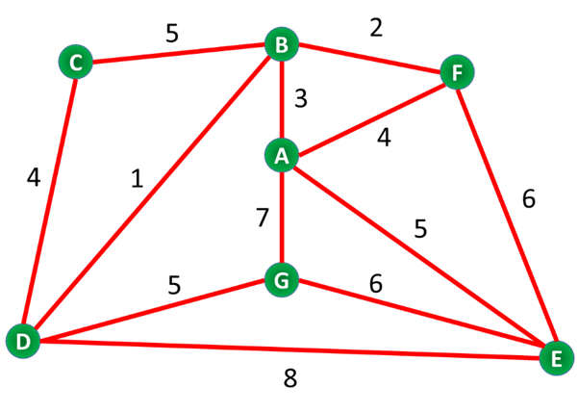

Numbers on the edges represent distance in 100s of meters, e.g. 7 represents 700m

a) Considering the graph above, state the degree of vertices G and A.
Do not write here
1 mark

Vertex | Degree
G | 3
A | 4

b) Does this graph contain a circuit? If so, provide an example.
Do not write here
1 mark

Yes for example path BFEDC

c) Is this graph Eulerian or Semi-Eulerian? Briefly justify your answer.
Do not write here
1 mark
This graph is neither Eulerian or Semi-Eulerian because No route that travels
through each edge exactly once; need to repeat some edges.

PlugWholes Ltd has been hired to fix the roads in Market Drayton, by plugging numerous holes in their surfaces. All 12 roads in the graph above require this service.

d) Calculate the shortest distance to be covered by PlugWholes Ltd around the above neighbourhood, by considering Shortest Inspection Route.
Do not write here
2 marks

(4+5+1+5+7+3+8+6+5+2+4+6)+4+7=56+4+7=67

All phone cables in Market Drayton are distributed underground. PlugWholes Ltd were so careless that they somehow managed to damage the entire phone network in this neighbourhood. CannectMe Company has been therefore deployed to build a new, efficient network from scratch.

e) Apply Kruskal’s Algorithm to find the shortest total length of cable needed to create a network in Market Drayton neighbourhood (graph above). Draw the resultant MST.
Do not write here
3 marks

Question 13

You must answer all questions 13a, 13b and 13c.

a) State the trace and transpose of matrix A.
Do not write here
2 marks

$$A=\left(\begin{matrix}2 & 6 & -2 \\ 4 & -3 & 9 \\ -4 & 7 & 8\end{matrix}\right)$$

$tr(A) =$

$A^{T}=$

b) Perform the following operations:

Do not write here
2 marks
- $\left(\begin{matrix}3 & 2 \\ 2 & -2\end{matrix}\right)+\left(\begin{matrix}-3 & 4 \\ 6 & -5\end{matrix}\right)-\left(\begin{matrix}3 & -3 \\ 4 & 3\end{matrix}\right)=$

Do not write here
2 marks
- $\left(\begin{matrix}-1 & 2 \\ 5 & -4\end{matrix}\right)×\left(\begin{matrix}7 & 4 \\ 3 & -2\end{matrix}\right)=$

c) Rotate the following triangle by 90° in the Clockwise direction. Draw the result on the axes below.

Rotation matrix of $θ$ degrees anti-clockwise around centre (0, 0) is
Do not write here
5 marks
$$\left(\begin{matrix}cos⁡θ & -sin⁡θ \\ sin⁡θ & cos θ\end{matrix}\right)$$

y
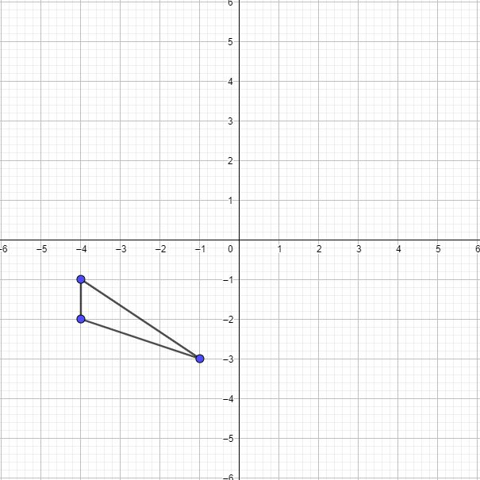
x

Question 14

UK’s general election took place in December 2019 and it was the first time young Ziutek cast his vote. Ziutek has been approached by his friend Dzesika, who is keen to learn who Ziutek has voted for. Ziutek decides to tell Dzesika – but not directly. He passes her the following numbers:

21 59 48 42 35 22
-9 -22 -15 -20 -5 -4

Dzesika also receives a Key to decrypt the message. Use the Key to find out Ziutek’s political affiliation:

Key: $\left(\begin{matrix}2 & 1 \\ -1 & 0\end{matrix}\right)$
Taking A =1, B = 2, C =3 etc. decrypt the message and help Remus find out what Ziutek voted for.
For Office Use Only
5 marks

END OF PAPER
Formulae Sheet

Object in Motion
$\frac{Difference in Distance}{Difference in Speed}=Time to catch up$
----------------------------------------------------------------------------------------------------------------------------------

Percentage increase/decrease
$\frac{New Value - Old Value}{Old Value}×100=Percentage increase/decrease$
----------------------------------------------------------------------------------------------------------------------------------
The area of circle πr²
Where π= 3.14, r = radius
----------------------------------------------------------------------------------------------------------------------------------
The area of a triangle $\frac{b × h}{2}$
Where b= length of base and h = height
----------------------------------------------------------------------------------------------------------------------------------
The volume of a cylinder πr²h
Where π =3.14, r = radius and h = height of cylinder
----------------------------------------------------------------------------------------------------------------------------------
The volume of a cone $\frac{1}{3}$πr²h
Where π =3.14, r = radius and h = height of cone
-----------------------------------------------------------------------------------------------------------------------------------
The volume of a sphere $\frac{4}{3}$πr³
Where π =3.14, r = radius
-----------------------------------------------------------------------------------------------------------------------------------

Probability

$\frac{Number of ways the event can happen}{total number of possibilities}=Probability$

P(A or B) = P(A) + P(B)
P(A) and P(B) = P(A) X P(B)
P(A) or P(B) =P(A) + P(B) - P(A and B)
----------------------------------------------------------------------------------------------------------------------------------

Binary Search Algorithm
$$Rank/Position= \frac{n+1}{2}$$

Where: n = the number of data points in the data set

Appendix:

Russian Peasant Algorithm

For multiplying $x×y$
- Write down two numbers you are multiplying in the table.
- Divide $x$ by 2 and write down the result underneath$x$, ignoring any decimals. For example, if the result was 4.5, write 4.
- Multiply $y$ by 2 and write down the result underneath$y$.
- Repeat steps 1-3 for the numbers in the new row. Keep going until the number in the $x$ column is 1.
- Look at your table. Cross out any row that has an even value for$x$.
- Add up the remaining numbers in y column. The result is the solution of $xy$, i.e. multiplying your original numbers
--------------------------------------------------------------------------------------------------------------------------

Length of Shortest Inspection Route

Eulerian | Semi-Eulerian | 4 odd Vertices
Length of Inspection route  =  Weight of full network | Length of Inspection Route  =  Weight of full network  +  Weight of the Shortest Path  between 2 odd vertices | Length of Inspection Route  =  Weight of full network  +  Repeated Edges

--------------------------------------------------------------------------------------------------------------------------

Kruskal’s Algorithm

- List the edges in ascending order of weight.
- Pick the edge of least weight – it will start the tree.
- Look at the next edge on the list. If it forms a cycle, DON’T use it and go on to the next edge. If it doesn’t form a cycle, add it to a tree
- Repeat step 3 until all vertices are connected
--------------------------------------------------------------------------------------------------------------------------

Determinant

$A=\left(\begin{matrix}a & b \\ c & d\end{matrix}\right)$, then the determinant, denoted by det(A) or |A| is
$$\det\left(A\right)=ad-bc$$
--------------------------------------------------------------------------------------------------------------------------

Inverse
$A=\left(\begin{matrix}a & b \\ c & d\end{matrix}\right)$ is $A^{-1}=\frac{1}{det⁡(A)}\left(\begin{matrix}d & -b \\ -c & a\end{matrix}\right)$
--------------------------------------------------------------------------------------------------------------------------

2D Rotational Matrix around the origin

$$R=\left(\begin{matrix}\cos\left(θ\right) & -\sin\left(θ\right) \\ \sin\left(θ\right) & \cos\left(θ\right)\end{matrix}\right)$$
Where
$θ$ is the angle you rotate by in the counter-clockwise direction
--------------------------------------------------------------------------------------------------------------------------

Matrix Encryption & Decryption:


